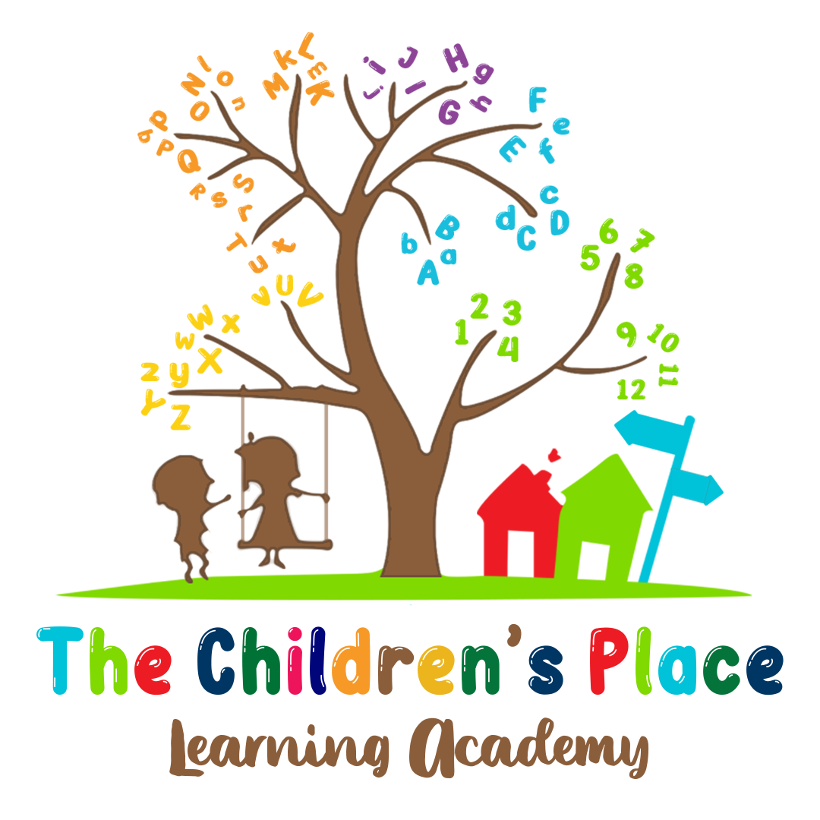

Parent Handbook

2301 Baton Rouge Ave
Lima, OH 45805
567.289.5212
viviannkids@yahoo.com

Welcome
Dear Family,
Thank you for choosing The Children’s Place Learning Academy. We look forward to providing your child with a caring and enriching environment with a broad comprehensive direction in child development. We are here to provide security, stimulation, physical, social emotional growth, and cognitive skills through play for young children.

Sincerely,

Vivian Kelley, Director

General Information

1. Contact Information
Many communication will be through email, verbal, letter or Brightwheel

The Children’s Place Learning Academy
2301 Baton Rouge Ave
Lima, OH 45805
viviannkids@yahoo.com
567.289.5212
For emergency after hours only: 419.204.3821

2. Program Philosophy
All students, regardless of gender, age, race, and/or physical limitations can and will learn up to their potential and will use the skills and knowledge learned to become well-rounded, well-educated, independent members of society.

MISSION STATEMENT
The Children’s Place Learning Academy will provide and maintain a safe, clean and nurturing environment that is conducive to learning and teaching. Our mission is to give children a headstart in their education by focusing highly on education and having them kindergarten ready.

VISION STATEMENT
Our vision is to promote growth that enables each child to develop social, emotional, and cognitive skills through play.
GOAL
It is our goal to provide children with the best educational opportunities and childcare.

3. Days and Hours of Operation
The Children’s Place Learning Academy is a year-round program. Our program is open Monday through Friday 6:30 a.m. and close at 5:30 p.m.
Instructional time starts at 9:30 a.m. daily.

Students must arrive by 9:00 a.m.

The Children’s Place Learning Academy is closed in observance of the following holidays:

New Year’s Eve, New Year’s Day, and The Day After
Martin Luther King
Good Friday
Memorial Day
Independence Day
Labor Day
Thanksgiving Eve, Thanksgiving Day, and the day after Thanksgiving
Christmas Eve, Christmas Day, and Day after Christmas

Note: Depending on the day Christmas falls on we may be closed the entire week.

The Children’s Place Learning Academy will close early on:
2-3 Training Days a Year with advance notice.

The program daily schedule:

6:00 - 8:00 a.m. Arrival, hand washing, free play
8:00 - 8:30 a.m. Clean-up
8:30 - 9:00 a.m. Restroom break, hand washing
9:00 - 10:15 a.m. Breakfast, hand washing
10:15 - 10:50 a.m. Calendar, Activities
10:50 - 11:00 a.m. Restroom break, hand washing
11:00 - 11:30 a.m. Outside time play
11:30 - 12:00 p.m. Restroom, Hand washing, structure
12:00 - 12:30 p.m. Lunch
12:30 - 12:45 p.m. Hand washing
12:45 - 2:30 p.m. Nap time
2:30 - 3:00 p.m. Restroom, hand washing
3:00 - 3:30 p.m. Snack time
3:30 - 3:45 p.m. Story time
3:45 - 4:15 p.m. Activity time
4:15 - 4:45 p.m. Structure play
4:45 - 5:00 p.m. Restroom, hand washing
5:00 - 5:30 p.m. Outside/pick up

*Toileting/ diapering: Done throughout the day and staff will change diapers every 2 hours or when diaper becomes soiled.

*Handwashing: done at appropriate times throughout the day

*Parents will provide lunch until further notice. The Children’s Place Learning Academy will have extra food on hand to ensure every child will have a nutritional meal.

*Closure due to weather – If the center would ever need to close unexpectedly (example: weather), local TV and radio and or Brightwheel. will help announce the closing. It should read The Children’s Place Learning Academy. The center also has a voicemail. Parents may call (567)289-5212 after 6:00 a.m.

4. Staff-to-Child-Ratios
Our staff-to-child-ratios meet or exceed state requirement and are as follows:

- Infants: 1 staff to 5 infants
- Toddlers - 2 ½ year-olds: 1 staff member to 7 toddlers or 2 staff members to 14 toddlers
- 3-year-olds: 1 staff member to 12 children or 2 staff members to 24 children
- 4/5-year-olds: 1 staff member to 14 children or 2 staff members to 28 children
- School -Age: 1 staff member to 18 children or 2 staff members 36 children
- Our center is licensed for 79 children

5. Parent involvement
Parents can be involved in activities in the following ways:
There will be times and ways parents can be involved in your child's experience. We welcome and encourage parents to participate. Some examples of ways to be involved, volunteer to read during story time to children, participate in art activities. Join in for celebration, child’s birthdays, and holiday celebration. I expect parents to be partners in their child’s care and encourage parents to volunteer for activities, birthday parties etc. whenever possible. I know parents are busy, and it is difficult to always find time to talk, but daily communication helps me to better meet your needs and the needs of your child.

6. Parent/Provider Meetings
Parent meetings:
Your involvement in your child’s education is very important to his/her educational success. We encourage parents to become involved by keeping the line of communication open and by participating in events and other school functions. Some other ways of becoming involved may include, but are not limited to:

- Meeting with teachers for formal or informal conferences
- Sharing a special talent or activity with child’s class
- Making visits to classrooms (Due to COVID-19 Parents are not allowed to do drop in visits)
- Helping your child’s teacher prepare classroom materials.
- Attending special events sponsored by the center.
- Sign weekly/daily folder
- Parents must provide formula, diapers, pampers, and wipes.

Note: Please inform your child’s teacher if you would like to visit.

7. Payment Policies
Payment Schedule:

Tuition is due on the FRIDAY before the following week, payments are late on MONDAY. No exceptions.
Payment will be accepted in Brightwheel (NO CHECKS OR CASH ACCEPTED)

Overtime/late Pick-up Policy and Fees:
A late fee of $10 will be added for any payment received after 9:00am on Monday, and an additional fee of $5.00 per day will be charged. If payment is not received by Tuesday morning, your child will not be able to participate in the program. No exceptions.

Late Fees:
Late fees for late pick-ups will be $5 PER MINUTE after the first 5 minutes. This amount MUST be paid by CASH to the staff member on duty that evening or the following morning. Please be responsible and take care of your obligation. Your late fee must be paid before your child returns, this will be strictly enforced.

If your child has not been picked up within one hour of the center’s closing time, we are required to call Children’s Protective Services

Supply Fees:
$50 per child (non-refundable)

Weekly Tuition:
$220 per child (6 weeks-18 months)
$189.70 per child (18 months-2 years)
$165.56 per child (ages 3, 4, and 5)
$151.20 per child (School Age: full time; summer)
$125 per child (School Age: Before and after school)

Half-day/ Part-time tuition (3 full days or AM/PM years) If space permits)
$100 per child (2 years -12
$150 per child (infant – 2 years)

8. Supports for Breastfeeding Mothers
Breastfeeding Mothers:
Parents have the right to send breast milk or breastfeed while your child is in care. Please label all bottles/cups with the child’s first and last name and date prepared.

A comfortable place (Calming Room) will be provided to enable a mother to breastfeed while the child is in care.

Policies and Procedures
1. Enrollment Information
An enrollment form must be completed:
In order for your child to be enrolled, information will need to be provided to the center. Child Health Enrollment forms along with a pick-up form and a physical will need to be submitted. These forms need to be submitted prior to your child attending the program. The physical form has to be submitted within 30 days of the child beginning at the center. If your child has allergies or other health concerns, there are also forms that will has to be filled out and submitted before the child begins.

2. Care of Children Without Immunizations
My program does provide care to children who have not been immunized.
If you choose to not immunize your child for any reason, your child will still be accepted in our center. You will need to provide a letter as to why you choose to not vaccinate your child and this letter will have to be updated annually.

3. Attendance Policies
Arrival and Departure Policy:
For safety reasons during drop-off and pick-up times please be in control of your child. Children will be received at 6:00am and parents must bring their child into the center and sign in upon arrival and leave it in the care of a designated center employee. If a child is picked up by someone who is not on the pick-up list, parents must inform the center in advance. That person MUST show their driver’s license before the child is released.

Absent Day Policy:
Each child is expected to arrive by 9:00am. If your child is going to be absent, please call the center and let a staff member know ahead of time. If a child is absent 3 consecutive absences, he/she must return with a doctor’s excuse to the center.

Sickness, including COVID-19, does not constitute a prorated rate.

Disaster Tuition
If a natural disaster occurs, tuition will be waived only for the full weeks we are closed.

Children Arriving from Other Programs:
Children coming from other programs will be checked in by staff members. If a child does not arrive from another program or activity, I will call the parent. If I cannot reach the parents, calls will be made to Emergency Contacts people.

4. Supervision
Supervision and Safety of the Children

- Upon arrival at and departing from the center, families are to sign children in and out in the notebook located at the reception desk located in the main entrance.

- Parents are to walk their child to their classroom and acknowledge to a staff member that the child is present before leaving. Children are to always remain in parent’s sight.

- As each child arrives and departs from the center, a staff person in the classroom takes attendance so that every child is accounted for throughout the day. (ex. When going outside, in case of a fire drill, etc.) Children coming and going from another program during the day will be counted in and out twice to account for their whereabouts.

- Whenever families have a change of home address, home phone number, change of work phone number, extension, cell phone, pager, etc., it is important that the center is notified so that parents can be reached at all times.

- Parents are required to fill out a release form for their child. These persons are authorized to pick up children from the center on a regular basis. In case of an emergency or scheduling conflict, parents are to notify the center in writing or by phone with specifics on who is picking up, time they are coming, ect. That person will need to show identification before taking the child.

- In situations where the child does not live with both parents, custody information will be required. The staff will be notified of this information and the center will enforce the agreement.

- No child is ever left alone or unsupervised while at the center. The only exception is that summer school-agers have bathroom and errand privileges.

- When a child is ready to move into the older age group, parents are given information about the new class, staff persons, schedules. Changes, etc. Parents are also given information on when “visiting days” will happen, and when the official “moving day” will occur. Staff/parents both sign the transition plan, and a copy is given to the parent.

- Teachers all conduct assessments on the children in the corresponding classrooms. This information is shared with the parent at the end of the year during a conference with the parent. We do not report this information to the Ohio Department of Job and Family Services.

5. Child Guidance
Behavior expectations:
Your child is treated with love and respect. When it comes to behavior, no one expects any child to be perfect. Many children have bad days, don’t want to share, tell teachers “NO”, ect These things are the norm. Sometimes, though, some behaviors call for some kind of guidance in correcting that behavior.

When a child does something inappropriate, our staff will calmly walk to the child, get on the child’s level and ask questions to get to the causes of the problem. By talking WITH the child, not AT the child, we can establish what caused this conflict. By doing this, we can also help teach the child how to deal with this problem appropriately the next time it happens. At that time, the child may need to be redirected to a different activity.

Sometimes the above steps may not produce what we feel is a successful response. At that time your child will be separated from the group for a few minutes to give the child time to collect his/her thoughts. (And time for the teacher to decide what step comes next!) In more serious cases, the following options are available depending on the situation:
- The child will be taken to see the director and spend some time in the office away from the class.
- The child’s teacher will send a note home detailing what happened throughout the child’s day and what he/she did to try to help the child with his/her behavior.
- The director and the head teacher will call a conference with the parent/parents.
- When behavior becomes too problematic the child will not be permitted to finish out the day and a parent will be asked to pick him/her up.

At the director’s discretion, If the issue cannot be resolved and repair the relationship a parent may be asked to withdraw the child from the center.

All employees of the center will follow this policy.

7. Americans with Disabilities Act Compliance Policies
Children with disabilities:
A child with special needs is assessed on an individual basis to determine if the program is the right fit for their needs. We will attempt to meet the needs of children with disabilities within our ability. Prior to caring for a child with a disability, my staff and I who are responsible for caring for the child are properly trained regarding any necessary procedures.
- Care Evaluation must be completed.
- Tuition will be based on additional staffing needs.
- All equipment, supplies, special food, speech supplement, physical therapy will be the responsibility of the parent.
- Periodic care evaluation will be done to ensure proper care of the child.
- As my program does not administer medication, I do not administer medication to any child.
- It is unlawful to discriminate in the enrollment of children upon the basis of race, color. religion, sex., or national origin or disability in violation of ADA Act of 1990, 104 Stat.32,42U.S.C.12101et seq.

8. Outdoor Play
Outdoor play including limitations to outdoor play because of weather or safety issues:
The Center will provide outdoor play each day in suitable weather for toddlers. Preschool and school-age children. We will also provide outdoor play in suitable weather for latchkey.

Providing outdoor play is essential to early childhood growth. Suitable weather is at a minimum twenty-five to ninety degrees Fahrenheit. We do not go outside when the temperature is below 25 degrees (including wind chill), or above 90 degrees (including heat index). There will be no outdoor play when it is raining, sleet or storms. Please make sure that your child has appropriate clothing for the weather outside. Students should wear closed shoes every day.

Activities for indoor play if weather doesn’t permit.
Reading, Sensory Bin, Puzzles, Sponge Painting, Cosmic Kids Yoga and Dance Educational Games ABC Mouse, Leap Frog.

9. Food and Dietary Policies
Parent Provided Food and Provider Dietary Policy:
- Have a safe storage for parent provided food.
- Provide all parents and staff with information regarding 1/3 of a child's recommended dietary allowance.
- A copy of this written nutritional form will remain on file at the center.

Provider Dietary Policy guideline:
- Follow a healthy dietary pattern for children served from six weeks to twelve years old.
- Focus on meeting food group needs
If a child has a food allergy, a doctor’s slip will be needed.
If a child’s religion or culture prohibits the eating of any food the center will offer a substitute provided by the parent. A written request will, however, need to be on file
- Juice supplied by the center is 100% fruit or vegetable juice.

The Children’s Place Learning Academy will have extra food on hand to ensure every child will have a nutritional meal.

*In accordance with Federal law and U.S Department of Agriculture policy, this institution is prohibited from discriminating on the basis of race, color, national origin, sex, age, or disability. To file a complaint of discrimination, write USDA, Director, Office of Civil Rights, Room 326- (202) 720-5964 (voice and TDD). USDA is an equal opportunity provider and employer. This institution is an equal opportunity provider. *

10. Illness Policies
Management of Illness (including whether the program will care for sick children, isolation, symptoms for discharge):

- If your child is sick or does not feel well enough to participate in program activities, please keep them at home.

- Sick children with a fever, diarrhea, continuous cough, or continuous runny nose, may not be brought to the center for care.

Return Policy for Children Who Have Been Ill:
Childhood illnesses are a part of growing up. Children absent from the center due to an illness may not return to the center without a signed release statement from a physician indicating that the child can return to the program. Parents should keep the center staff updated daily so that we may hold the child’s spot if he/she is going to return after the Illness. However, if an illness occurs affecting children in the center a letter will be posted of precautions to take, and parents will also be notified.

Sick Children:
Students who have been sent home will not be permitted to return for a period of 48 hours.

Notification of Ill Child:
If your child becomes ill while in our care, parents will be called immediately to pick them up, or make arrangements to have them picked up. The child will be removed from the classroom and isolated until they are picked up.

11. Emergency, serious illness and injury procedures
In case of an emergency or a serious illness, 911 will be called to transport the child to the hospital. The child’s health and medical records are to accompany the child. The center administrator or a childcare staff member is to stay with the child until the parents assume responsibility for the child’s care.
If your child becomes ill while in our care, you will be called immediately. The child will be removed from the classroom and isolated until you pick him up.

An injury resulting in a child being able to return to normal activity, basic first aid may be given by the provider. A copy of JFS 01299 reports will be given to parents and shall be retained on file at the program for at least one year and shall be available for review by ODJFS.

12. Administration of Medications and Tropical Products Policies
As my program does not administer any type of medication, I do not administer medication to any child.

Medicine WILL NOT be administered by the staff.

School Age Children and Medication:

The rule for administration of Medication above would apply for school, age children also.

13. Transportation Policy
Currently, The Children’s Place Learning Academy does not offer transportation to and from school. If this changes, parents will be notified

Transportation for Trips:
Currently, The Children’s Place Learning Academy does not offer off site trips.

Transportation for Emergencies:
In case of an emergency or a serious illness, 911 will be called to transport the child to the hospital. The child’s health and medical records are to accompany the child. The center administrator or a childcare staff member is to stay with the child until the parents assume responsibility for the child’s care.

14. Water Activities and/or Swimming
At this time The Children’s Place Learning Academy will not participate in water activities on site. If this policy changes parents will be notified.

15. Infant Care and Diaper Procedures (all ages)
At this time The Children’s Place Learning Academy is accepting infants.

Diaper procedure:
Parents must provide all diapers and wipes as necessary.
Diapers are checked at least every two hours and are changed immediately when wet or soiled.
Diapers changes are recorded on each infant’s daily record.
Children must have their bottles clearly labeled with their name and their appropriate formula.

16. Sleeping, Napping and Resting Policies
All children in the center prior to being school-age are given a cot or crib for nap time.
Center nap time is 12:45 – 2:30 p.m. The children are not required to take a nap but
we will try to get them to sleep or rest before giving them something to keep them
occupied during nap time.
This schedule may be altered due to special programs.
In accordance with minimum standards, staff must provide a supervised sleep or rest period for all children 18 months and older in care for five or more hours. All children in the center prior to being school-age are given a cot or crib for nap time. A rest period is scheduled in each classroom each day to balance the active time. We, as adults, are aware that not all children will sleep. However, all children will be encouraged to lie down and rest during this time. Generally, nap time will be from 12:45 – 2:30 p.m. The rest period will not exceed 3 hours. This schedule may be altered due to special programs.

17. Evening and Overnight Care
Overnight Care: Currently the program does not provide overnight care.

Evening Care:
- My evening child care program has additional policies for children attending after 7 p.m. and before 6:00 a.m.
- Children under age 5 will always sleep on the same floor as the staff
- Staff will remain awake until all children are asleep
- The children sleep only in areas approved for sleeping
Children will brush their teeth prior to sleeping

18. Policies on Hours of Operation Including Closures Due to Weather, School Delays or Closings, and Other Factors
Except for scheduled holidays, the center remains open unless there is a weather or other emergency that results in a lack of power, heat, and/or running water.
In the case of closure, families will receive a phone call or text message as soon as I know the program will close.
Closure due to weather – If the center would ever need to close unexpectedly due to weather, local TV and radio will help announce the closing. It should read The Children’s Place Learning Academy. The center also has a voicemail. Parents may call (567)289-5212 after 6:00 a.m.

19. Using Child Care Staff Members or Substitute Child Care Staff Members Policy:
Staff should know where the center has secured files, and verification of a medical examination for each child enrolled. The administrator shall review all child care policies, procedures and licensing rules with each child care staff member. Meet all training requirements CPR, First Aid, Communicable Disease and \ completes the staff orientation training as prescribed by the Ohio department of job and family services (ODJFS) within thirty days of starting employment.

20. Disenrollment Policy:
If you plan to withdraw your child from the program, please notify the center director at least two weeks ahead of time or as soon as you know when his/her last day will be. The director will then notify the teacher who will in turn prepare the class and your child for departure.

I reserve the right to dismiss any child at any time, with or without cause. Below are some reasons why I would have to disenroll as a child or family.

• Child unable to adjust to the program after a reasonable amount of time
• Ongoing physical or verbal abuse to staff or other children
• Ongoing uncontrollable tantrums/angry outbursts
• Excessive biting
• A parent/guardian fails to abide by policies or requirements imposed by the appropriate licensing
• Non-payment
• A parent/guardian is physically or verbally abusive or intimidating to Center staff, children, or anyone else. Potentially dangerous behavior by a parent or child.

21. Conflict Resolution Policy:
It is important that there is communication and trust between staff and the parents. I will always welcome questions, feedback, of any kind. If conflict arises, there will be a meeting scheduled to discuss the issue. If the issue cannot be resolved and repair the relationship, it may be necessary for the parent find a new childcare center.

22. Assessments
Formal Child Assessment Policy:
Formative assessments are given within 30 days after the child has been enrolled in the program. Our program utilizes screening, process monitoring tools, and formal assessment to ensure that the children’s learning needs are being met.

Miscellaneous

SCHOOL PORTRAITS
The Children’s Place Learning Academy provides, for your convenience, a quality photograph program throughout the year. Photo opportunities may include individual portraits, holiday portraits, and class portraits at the cost of the parents.

SPECIAL DAYS/BIRTHDAYS
We do allow birthday parties at the center. However, we request that parents give a 48-hour notice so the teacher can prepare. The allotted time for birthday celebrations is during snack time at 2:30 pm.

Holidays celebrated: Christmas, Thanksgiving, Valentines, Independence Day, Cinco de Mayo, President’s Day, Dr. King birthday

IN-HOUSE EVENTS
A notice of in-house events will be posted at least 48 hours in advance when possible. The Children’s Place Learning Academy will maintain a monthly newsletter as well as an activity board.

PERSONAL ITEMS
We ask that you discourage your child from bringing his/her personal treasures such as toys, watches, rings, earrings, etc. to the center. We will not be responsible for replacement of lost, misplaced or broken personal items. Personal items may be requested by individual teachers for SHOW AND TELL. It will be up to the parent and child to decide whether or not to bring items at this time.
ALLERGIES
If your child has any allergies, please make sure to fill out the Allergies form in the enrollment packet and discuss it with the center director so that we may take necessary precautions. A doctor’s note is required for all allergies. Allergies will be communicated to staff, teachers, and the kitchen staff.

If your child has been prescribed an Epi-pen, it is your responsibility to provide it to the school in case of an emergency.

ALLERGIC REACTION ACTION PLAN
If a child has an allergic reaction while at the center:
- Emergency medical support will be requested as needed.
- The Epi-pen will be administered if child has one prescribed on file.
- Parent will be notified.

THE EDUCATION PROGRAM
The Children’s Place Learning Academy will use a blended curriculum and best practices in the classroom. Art projects, music, storytelling, math, literacy, science experiments, social-emotional development and physical development will be included in the curriculum. We realize that all children work and learn at their own pace. This learning will be guided and monitored by your child’s teachers.

Your child will participate in activities such as, but not limited to the following:
Literacy, Math, Science, Social Studies, computers, weekly music, beginners American Sign Language, art, working with paints, clay, manipulative, movies, cultural activities and in-house events. A copy of the activity schedule will be posted in each classroom.

GENERAL NOTICES
General notices, announcements, calendars, menus, and special bulletins will be posted in brightwheel. Notices will also be posted at the front entrance.

PARENT GRIEVANCE
If you have a grievance, please bring it to the attention of the center director as quickly as possible so that it can be resolved expediently.

TAKE HOME FOLDER
All full-time students will be provided with a “take home” folder. Please review nightly.
WITHDRAWALS
If you plan to withdraw your child from the program, please notify the center director at least two weeks ahead of time or as soon as you know when his/her last day will be. The director will then notify the teacher who will in turn prepare the class and your child for departure.

FIELD TRIPS
The Children’s Place Learning Academy will not participate in field trips at this time. If this changes, parents will be notified.

ZERO TOLERANCE POLICY
Tobacco, drugs, alcohol, and weapons will not be allowed on the center’s premises. Students found with the same will be automatically dropped from the program. Obscene language, fights, and/or assaults will not be tolerated. Any student that violates this policy may be subject to a full one-day suspension from the center. Staff and parents under the influence of drugs and/or alcohol will not be allowed on the premises and, if necessary, the local law enforcement will be called.

SOCIAL MEDIA AND INTERNET POLICY
The Children’s Place Learning Academy, teachers, students, staff, and other school community members use social networking/media/internet (Twitter, Facebook, blogs, etc.) as a way to connect with others, share educational resources, log experiences, create educational content, enhance the classroom experience, and network within and outside of the school community.

While social networking and the internet is fun and valuable, there are some risks we need to keep in mind when using these tools. We expect good judgment in all situations and behave in a way that will make you and others proud and reflect well on the school.

If you do not wish for your child to be highlighted on social media or have access to our online education programs, please let us know in writing.

THE CHILDREN’S PLACE LEARNING ACADEMY COVID-19 POLICY
This policy has been created using a combination of guidelines and recommendations from the CDC, the Allen County Health Department. All parents are expected to monitor their child’s health, and to keep them home if they display any symptoms of sickness. The staff is also expected to monitor the student’s health and presence of any symptoms.

If any child or staff is exposed to COVID-19 or test positive you must notify the school ASAP.

COVID-19 Results
Positive COVID-19 Results

If the child or staff member tests positive for COVID-19 The Children’s Place Learning Academy is required to contact Allen County and Health and Department. They will give recommendations on any classroom closures.

The COVID positive student or staff and household should quarantine, and the child or staff may not come to daycare for a minimum of 14 days. After the 14-day quarantine, if no one in the household has experienced and COVID-19 symptoms, the child may return to daycare on day 15. In addition, a negative result is required to return.

Exposure to COVID-19 not positive.
If someone in the child’s household (even a part-time member) has been exposed to an individual who has tested positive for COVID-19 or a household member test positive, the household should quarantine, and the child may not come to daycare for a minimum of 14 days. After the 14-day quarantine, if no one in the household has experienced any COVID-19 symptoms, AND the exposed person has tested negative (with a minimum of 5 days passing between exposure and testing), the child may return to daycare on day 15. In addition, a negative result is required to return.

If the exposed person is not tested, the child may not come to daycare for a minimum of 20 days. If no one in the household has experienced and COVID-19 symptoms, the child may return to daycare on day 21.
Please note that should any of the above scenarios occur, it is your responsibility to notify The Children’s Place Learning Academy immediately so the appropriate actions can be discussed and taken.

Please note that should any of the above scenarios occur, payment will still be required.

FIRE DRILL, SEVERE WEATHER, AND DISASTERS
The staff and children practice fire and severe weather evacuation and safety drills monthly. In case of fire, we will evacuate the premises and relocate to another location. All parents will be notified of our whereabouts as soon as possible. Fire and weather disaster evacuation routes are posted in each room.

EMERGENCY PREPAREDNESS PLAN
The Children’s Place Learning Academy does have a comprehensive Emergency preparedness plan. A full copy can be provided if requested.
Provided that an emergency occurs that requires us to move from the site, we will move to a safe location.

- The Lima Mall 2400 Elida Rd, Lima, Oh 45805 - This business is within walking distance of the Learning Academy.

- Elida Fire Department 2110 Edgewood Dr, Lima, Oh 45805 - This business is within walking distance of the Learning Academy.

If moved, we will follow the following steps:

- Ensure we have all children in care accounted for
- Notify the appropriate emergency authority
- Move Children to the closest and most appropriate safe location
- Notify parents

CHANGES IN POLICIES
If there are any changes in policy, parents will be given the change in writing.

CHILD ABUSE
The Children’s Place Learning Academy will continuously participate in training to make us premiere child caregiver. This includes required training about child abuse and neglect. We also share with parents how to reduce the risk of abuse and neglect, prevention of child abuse, and signs of abuse and neglect.

EQUAL OPPORTUNITY PROVIDER
The Children’s Place Learning Academy is an equal opportunity provider. Enrollment packets are available and accepted without regard to race, sex, national origin, disability, religion, or political belief. If you believe that you have been discriminated against by this center because of one of the above, you may file a complaint against this center by calling or writing to the Office of Civil Rights, 30 East Broad St, Columbus, OH 43215, phone: 888-278-7101.
WEAPONS POLICY
The Children’s Place Learning Academy provides a safe and nonviolent environment for our students, parents, and staff. To ensure safety firearms, darts, knives, cap pistols will not be permitted at any time.

Center Parent Information -
Appendix 5101:2-12-07

Student(s) Name_________________________________________________
Parent/ Employee Name_________

The center is licensed to operate legally by the Ohio Department of Job and Family Services (ODJFS). This license is posted on the Parent Board in the front entryway of the building.

A toll-free telephone number is listed on the center’s license and may be used to report a suspected violation of the licensing law or administrative rules. The licensing rules governing child care are available for review at the center.

The administrator and each employee of the center is required, under Section 2151.421 of the Ohio Revised Code, to report their suspicions of child abuse or child neglect to the local public children’s services agency.

Any parent of a child enrolled in the center shall be permitted unlimited access to the center during all hours of operation for the purpose of contacting their children, evaluating the care provided by the center or evaluating the premises. Upon entering the premises, the parent, or guardian shall notify the Administrator of his/her presence.

The administrator’s hours of availability to meet with parents and child/staff ratios are posted on the Parent Board in the front entryway.

The licensing record, including licensing inspection, reports, complaint investigation reports, and evaluation forms from the building and fire departments, is available for review upon written request from the ODJFS. Inspections are also online at http://childcaresearch.ohio.gov/. Parents, may search for a specific program and sign up to be notified when the program’s latest inspection is posted online.

It is unlawful for the center to discriminate in the enrollment of children upon the basis of race, color, religion, sex, national origin or disability in violation of the Americans with Disabilities Act of 1990, 104 Stat. 32, 42 U.S.C. 12101 et seq. To film a discrimination complaint, write or call Health and Human Services (HHS) or ODJFS. HHS and ODJFS are equal opportunity providers and employers.

Write or Call: Write or Call:
HHS ODJFS
Region V, Office of Civil Right Bureau of Civil Rights
233 N. Michigan Ave, Ste. 240 30 E. Broad St., 37th Floor
Chicago, IL 60601 Columbus, OH 43215-3414
(312) 886-2359 (voice) (614) 644-2703 (voice)
(312) 353-5693 (TDD) 1-866-277-6353 (toll free)
(312) 886-1807 (fax) (614) 752-6381 (fax)
1-866-221-6700 (TTY) or (614) 995-9961
For more information about child care licensing requirements as well as how to apply for child care assistance, Medicaid health screenings and early intervention services for your child, please visit http://jfs.ohio.gov/cdc/families.stm.

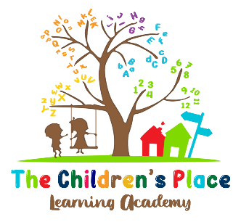

Acknowledgement of
Receipt of Handbook

I hereby certify I have read and fully understand the contents of The Children’s Place Learning Academy Parent Handbook.
I also acknowledge that I have been given the opportunity to discuss any policy contained in this handbook with a company official. I agree to abide by the policies set forth in this handbook and understand that compliance to the rules and regulation is necessary for continued enrollment and employment.

My signature below certifies my knowledge, acceptance, and adherence to the company’s policies, rules, and regulations.

I acknowledge that The Children’s Place Learning Academy has the right to modify or amend its policies at any time without prior notice.

Student(s) Name_________________________________________________

Student(s) Name_________________________________________________

__________________________________

Parent/EmployeeSignature_________________________________________

Date ___________________

